LAB #5

Download project starter files and deploy Azure services
In this section you download the project starter files and use a script to deploy the necessary services to your Azure subscription. The Azure Container Registry and Container Apps environment deployment takes a few minutes to complete.
- Open a browser and enter the following URL to download the starter file. The file will be saved in your default download location.
TypeCopy
https://github.com/MicrosoftLearning/mslearn-azure-ai/raw/main/downloads/python/aca-scale-python.zip
- Copy, or move, the file to a location in your system where you want to work on the project. Then unzip the file into a folder.
- Launch Visual Studio Code (VS Code) and select File > Open Folder… in the menu, then choose the folder containing the project files.
- The project contains deployment scripts for both Bash (azdeploy.sh) and PowerShell (azdeploy.ps1). Open the appropriate file for your environment and change the two values at the top of the script to meet your needs, then save your changes. Note: Do not change anything else in the script.
TypeCopy
$rg = "ResourceGroup1" # Resource Group name
$location = "<your-azure-region>" # Azure region for the resources
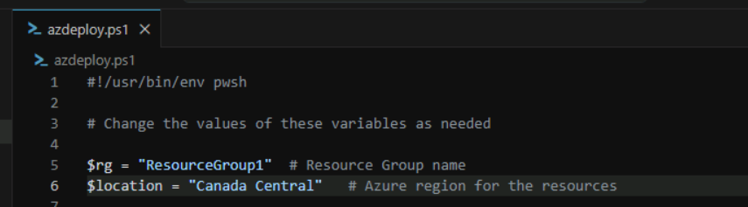
- In the menu bar select Terminal > New Terminal to open a terminal window in VS Code.
- Run the following command to login to your Azure account. Answer the prompts to select your Azure account and subscription for the exercise.
TypeCopy
az login
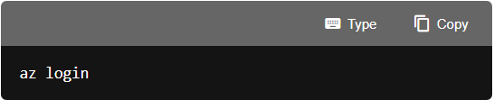

- Run the following command to ensure you have the containerapp extension for Azure CLI.
azurecliTypeCopy
az extension add --name containerapp
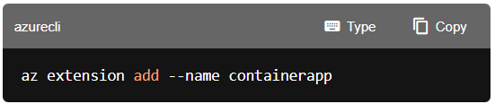

- Run the following commands to ensure your subscription has the necessary resource providers for the exercise.
azurecliTypeCopy
az provider register --namespace Microsoft.App
az provider register --namespace Microsoft.OperationalInsights
az provider register --namespace Microsoft.ContainerRegistry
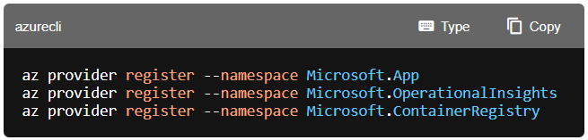
Create resources in Azure
In this section you run the deployment script to deploy the necessary services to your Azure subscription.
- Make sure you are in the root directory of the project and run the appropriate command in the terminal to launch the deployment script. The script deploys ACR, a Container Apps environment, and a Container App with ingress enabled. It also creates a file with environment variables you use throughout the exercise.
Bash
bashTypeCopy
bash azdeploy.sh
PowerShell
powershellTypeCopy
./azdeploy.ps1
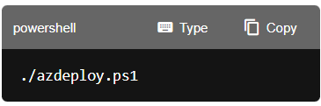

Note: If PowerShell blocks the script because it is not digitally signed, run the following command in the same terminal session, then run the deployment script again. This command changes the execution policy only for the current PowerShell process.
powershellTypeCopy
Set-ExecutionPolicy -Scope Process -ExecutionPolicy Bypass
- When the script is running, enter 1 to launch Create Azure Container Registry and build container image.
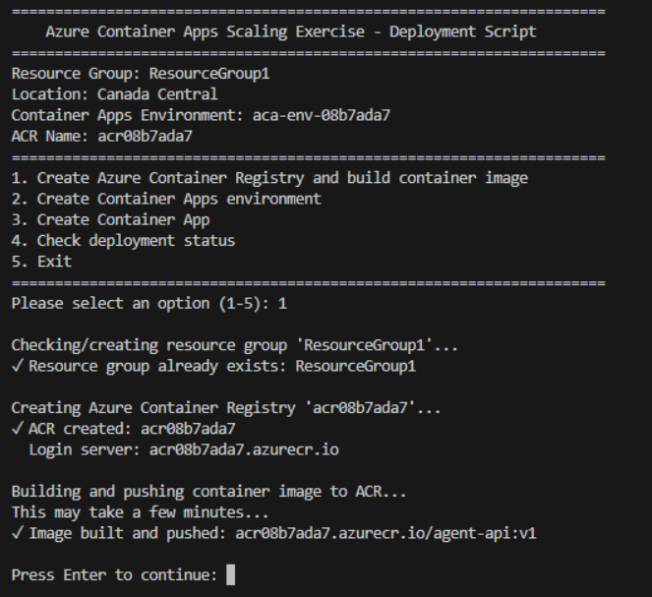
- When the previous operation is finished, enter 2 to launch Create Container Apps environment.
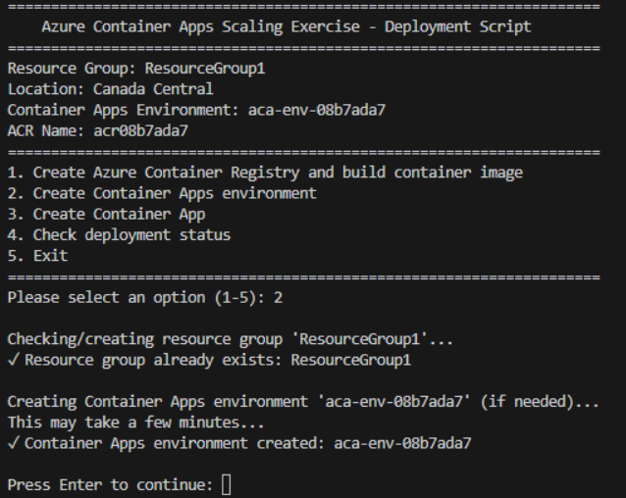
- When the previous operation is finished, enter 3 to launch Create Container App.
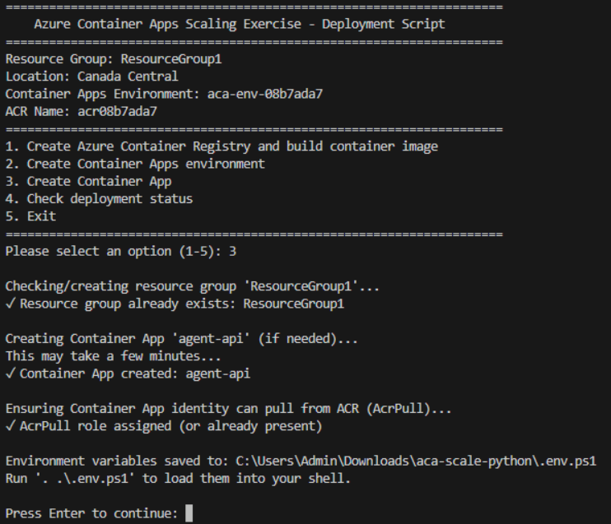

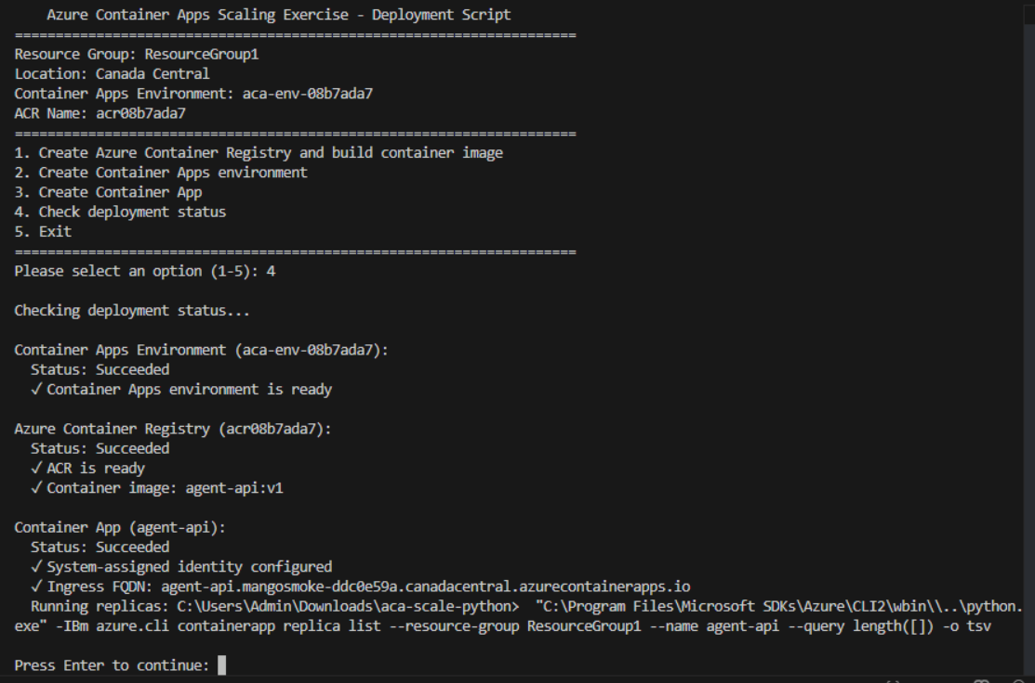
Note: A file containing environment variables “.env.ps1” is created after the container app is created. You use these variables throughout the exercise.
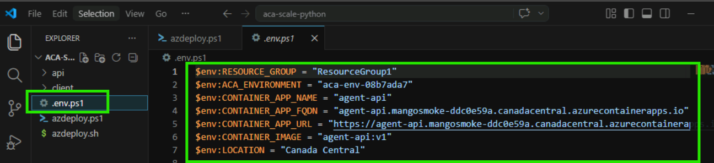

File: “.env.ps1”
$env:RESOURCE_GROUP = "ResourceGroup1"
$env:ACA_ENVIRONMENT = "aca-env-08b7ada7"
$env:CONTAINER_APP_NAME = "agent-api"
$env:CONTAINER_APP_FQDN = "agent-api.mangosmoke-ddc0e59a.canadacentral.azurecontainerapps.io"
$env:CONTAINER_APP_URL = "https://agent-api.mangosmoke-ddc0e59a.canadacentral.azurecontainerapps.io"
$env:CONTAINER_IMAGE = "agent-api:v1"
$env:LOCATION = "Canada Central"

- When the deployment completes, enter 5 to exit the deployment script.
- Run the appropriate command to load the environment variables into your terminal session from the file created in a previous step.
Bash
bashTypeCopy
source .env
PowerShell
powershellTypeCopy
. .\.env.ps1

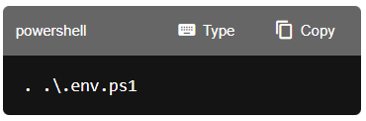
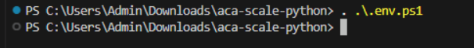

- Verify the app endpoint is available.
Bash
bashTypeCopy
curl -sS "$CONTAINER_APP_URL/" | head
PowerShell
powershellTypeCopy
Invoke-RestMethod "$env:CONTAINER_APP_URL/"
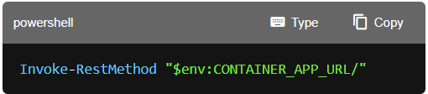
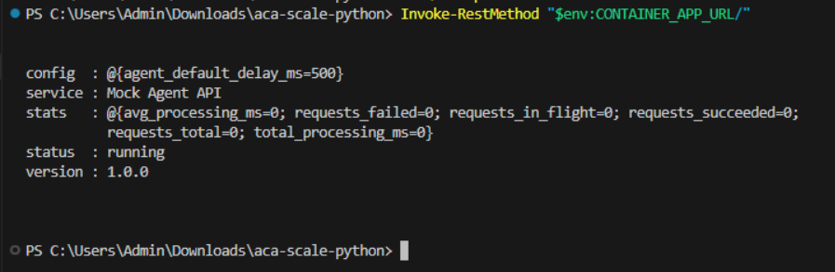
Note: Keep the terminal open. If you close it and create a new terminal, you might need to run the command to create the environment variable again.
Configure autoscaling
In this section you configure an HTTP scale rule that triggers scaling based on concurrent requests. This is a useful proxy for "agent requests in progress" without adding any other Azure services.
Note: Applying configuration updates (including scaling changes) creates a new revision.
- Run the following command to update the container app with an HTTP scale rule. This rule monitors concurrent in-flight requests and scales the app when demand increases.
Bash
bashTypeCopy
az containerapp update \
--name $CONTAINER_APP_NAME \
--resource-group $RESOURCE_GROUP \
--min-replicas 0 \
--max-replicas 10 \
--scale-rule-name http-scaling \
--scale-rule-type http \
--scale-rule-http-concurrency 10
PowerShell
powershellTypeCopy
az containerapp update `
--name $env:CONTAINER_APP_NAME `
--resource-group $env:RESOURCE_GROUP `
--min-replicas 0 `
--max-replicas 10 `
--scale-rule-name http-scaling `
--scale-rule-type http `
--scale-rule-http-concurrency 10
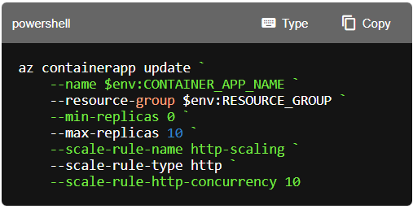
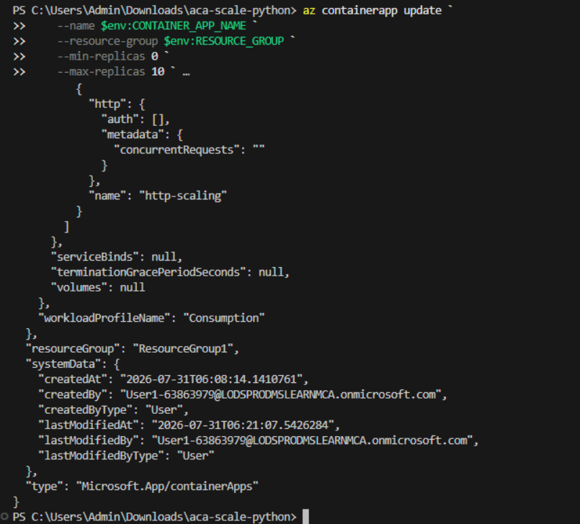
- Run the following command to verify the scale rule is configured. Look for the http-scaling rule in the output with minReplicas set to 0 and maxReplicas set to 10.
Bash
bashTypeCopy
az containerapp show \
--name $CONTAINER_APP_NAME \
--resource-group $RESOURCE_GROUP \
--query "properties.template.scale"
PowerShell
powershellTypeCopy
az containerapp show `
--name $env:CONTAINER_APP_NAME `
--resource-group $env:RESOURCE_GROUP `
--query "properties.template.scale"
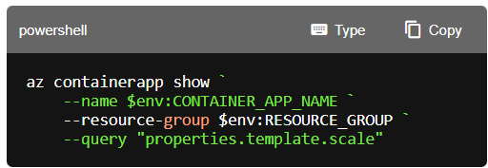
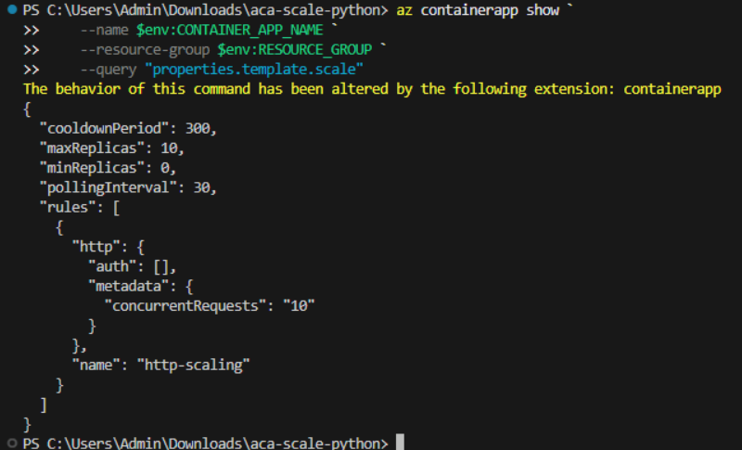

Generate load and observe scaling
In this section you run a local Flask dashboard that can both generate concurrent requests and show Container App revisions/replicas.
- Run the following command to navigate to the client directory.
TypeCopy
cd client
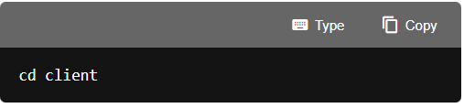
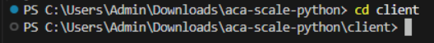
- Run the following command to create a virtual environment for the client app. Depending on your environment the command might be python or python3.
pythonTypeCopy
python -m venv .venv
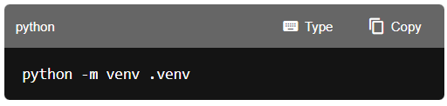

- Run the following command to activate the Python environment. Note: On Linux/macOS, use the Bash command. On Windows, use the PowerShell command. If using Git Bash on Windows, use source .venv/Scripts/activate.
Bash
bashTypeCopy
source .venv/bin/activate
PowerShell
powershellTypeCopy
.\.venv\Scripts\Activate.ps1
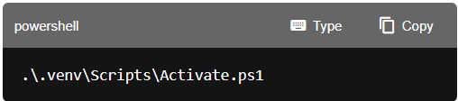

- Run the following command to install the dependencies for the client app.
bashTypeCopy
pip install -r requirements.txt
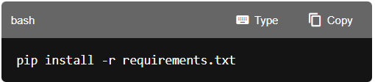
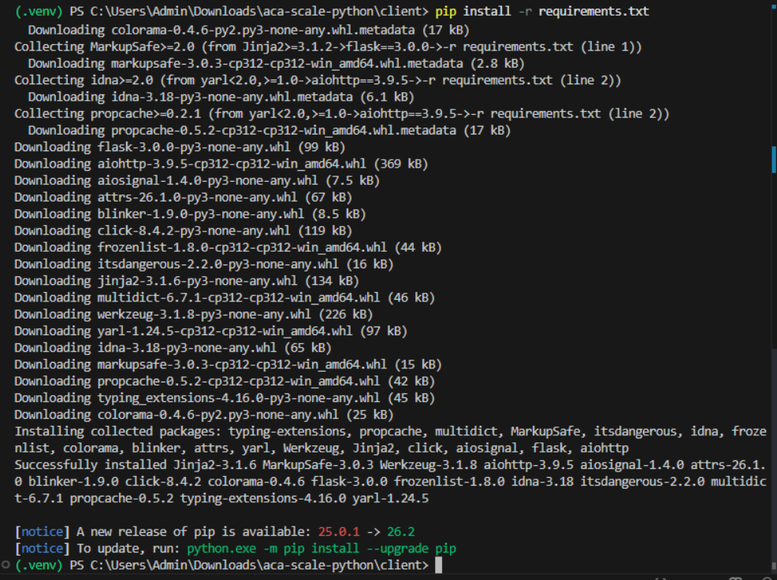

- Run the following command to start the dashboard.
TypeCopy
python app.py
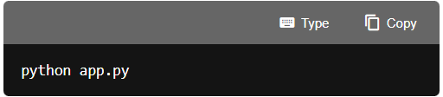
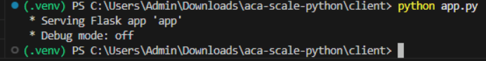

- Open a browser and navigate to the following URL: http://127.0.0.1:5000.
- In the left pane of the app select Refresh Revisions & Replicas. In the top right of the app you should see 1, or 0 replicas running.
When you deployed the app it defaulted to 1 running replica. You applied KEDA scale rule in a previous step and scaling down to zero may take an additional ~5 minutes after the workload becomes idle because of the default 300-second (5-minute) cool-down period.
- In the Load Generator section, select Start to being sending data to the container app.
- Select Refresh Revisions & Replicas every 5-10 seconds and you should see the number of replicas increase. You can run the Load Generator again after it stops to increase the traffic and increase replica count.
When you're finished close the browser window and enter Ctrl+c in the terminal to end the client app.
Configure scale rules using YAML
In this section you configure autoscaling by editing the Container App YAML. This is a repeatable way to manage scale rules, and it becomes essential when you have multiple rules.
- Run the following command to export the app configuration to a YAML file.
Bash
bashTypeCopy
az containerapp show \
--name $CONTAINER_APP_NAME \
--resource-group $RESOURCE_GROUP \
--output yaml > app-config.yaml
PowerShell
powershellTypeCopy
az containerapp show `
--name $env:CONTAINER_APP_NAME `
--resource-group $env:RESOURCE_GROUP `
--output yaml > app-config.yaml
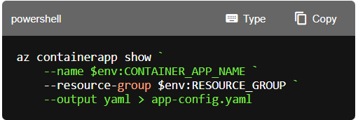
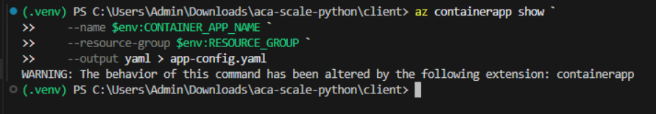
- Open the app-config.yaml file in VS Code. Find the scale section under properties > template. Modify the scaling configuration to reduce the cooldownPeriod to 200 seconds (faster scale-down), set maxReplicas to 5, and set minReplicas to 1 so the app always has at least one replica running. The scale section should look similar to the following example.
yamlTypeCopy
scale:
cooldownPeriod: 200
maxReplicas: 5
minReplicas: 1
pollingInterval: 30
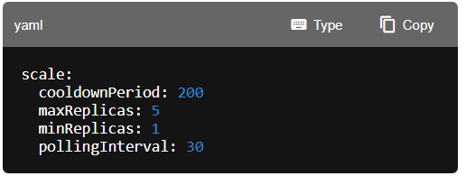
- Save the file and run the following command to apply the updated configuration.
Bash
bashTypeCopy
az containerapp update \
--name $CONTAINER_APP_NAME \
--resource-group $RESOURCE_GROUP \
--yaml app-config.yaml
PowerShell
powershellTypeCopy
az containerapp update `
--name $env:CONTAINER_APP_NAME `
--resource-group $env:RESOURCE_GROUP `
--yaml app-config.yaml
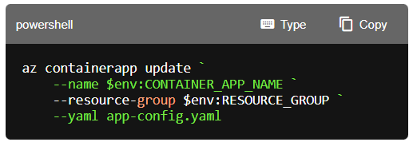
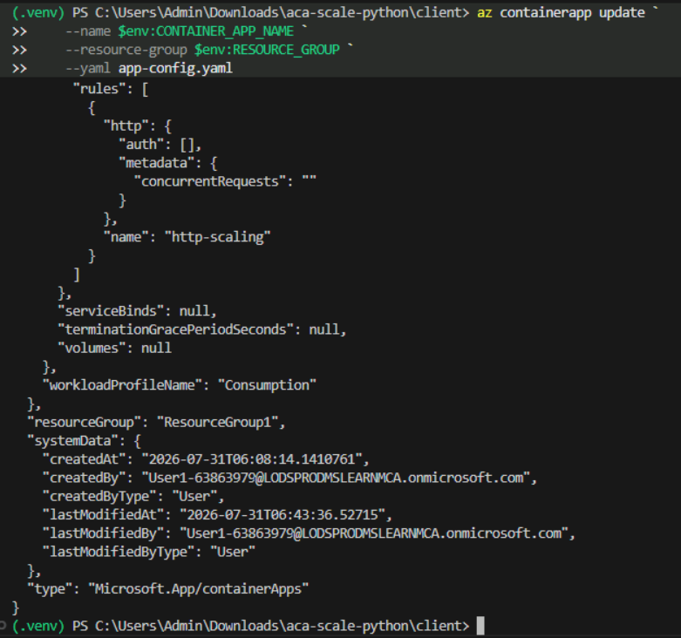

- Run the following command to verify the changes you just implemented.
Bash
bashTypeCopy
az containerapp show \
--name $CONTAINER_APP_NAME \
--resource-group $RESOURCE_GROUP \
--query "properties.template.scale"
PowerShell
powershellTypeCopy
az containerapp show `
--name $env:CONTAINER_APP_NAME `
--resource-group $env:RESOURCE_GROUP `
--query "properties.template.scale"
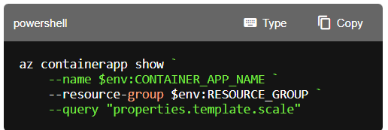
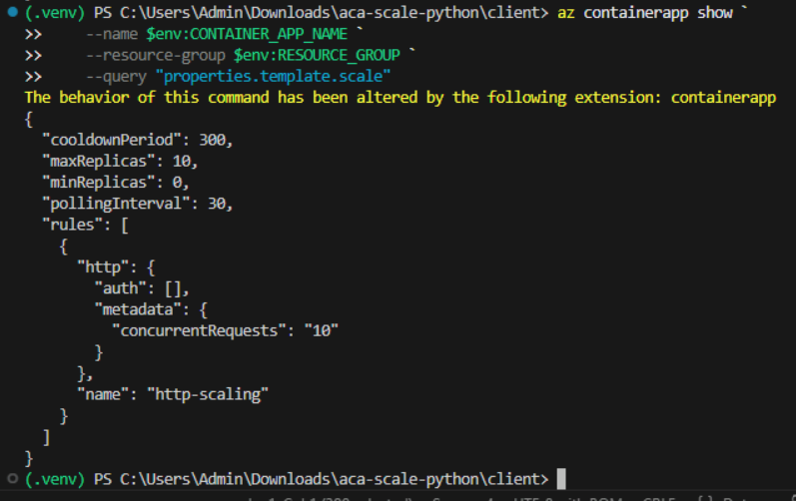
Clean up resources
Now that you finished the exercise, you should delete the cloud resources you created to avoid unnecessary resource usage.
- Run the following command in the VS Code terminal to delete the resource group, and all resources in the group. Replace \ with the name you choose earlier in the exercise. The command will launch a background task in Azure to delete the resource group.
TypeCopy
az group delete --name <rg-name> --no-wait --yes
CAUTION: Deleting a resource group deletes all resources contained within it. If you chose an existing resource group for this exercise, any existing resources outside the scope of this exercise will also be deleted.
Troubleshooting
If you encounter issues during this exercise, try these steps:
App not scaling out under load
- Verify the HTTP scale rule is configured:
az containerapp show --query "properties.template.scale" -g ResourceGroup1 -n agent-api 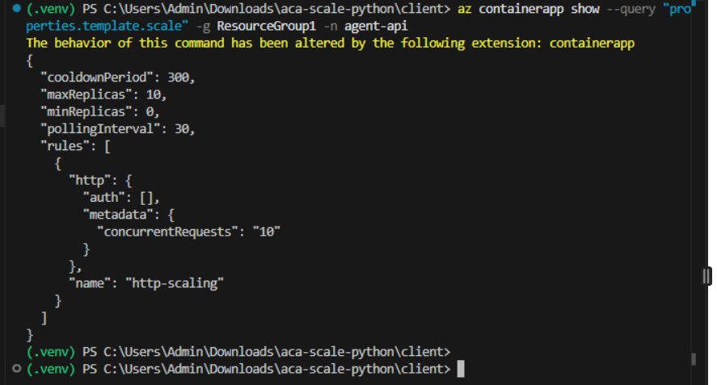
- Ensure you're generating concurrent requests (use the dashboard with delayMs > 0)
- Increase delayMs (500-1500ms) so requests overlap and concurrency accumulates
- Check system logs for scaling events: az containerapp logs show -n agent-api -g ResourceGroup1 --type system --tail 50
az containerapp logs show -n agent-api -g ResourceGroup1 --type system
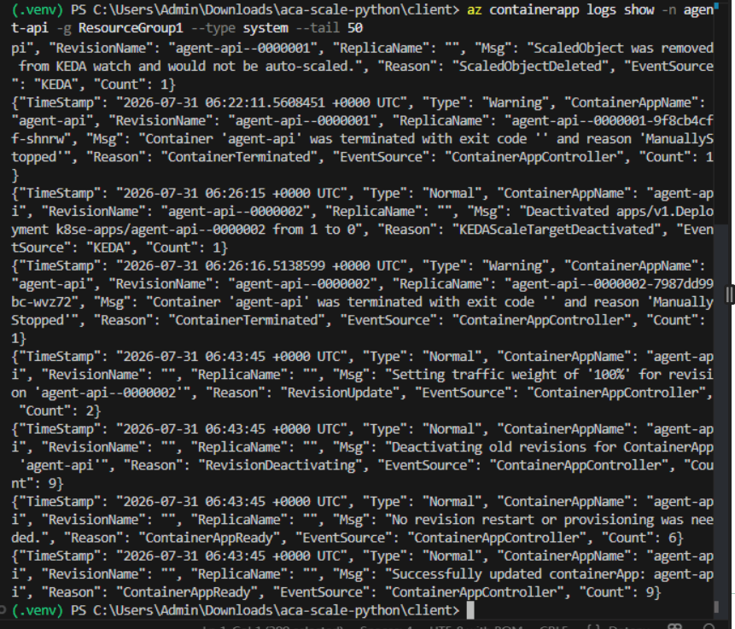
Dashboard won't start or can't list revisions/replicas
- Ensure Python virtual environment is activated (you should see (.venv) in your terminal prompt)
- Ensure dependencies are installed: pip install -r client/requirements.txt
- Ensure Azure CLI is installed and you ran az login
- Ensure the containerapp extension is installed: az extension add --name containerapp
- Ensure .env is loaded and contains RESOURCE_GROUP and CONTAINER_APP_NAME
Python venv activation issues
- On Linux/macOS, use: source client/.venv/bin/activate
- On Windows PowerShell, use: .\client.venv\Scripts\Activate.ps1
- If activate script is missing, reinstall python3-venv package and recreate the venv
YAML update fails
- Ensure the YAML file syntax is valid (check indentation)
- Some read-only properties like id, systemData, and type may cause errors; remove them if needed
- Verify the scale section follows the correct structure under properties > template > scale

Congratulations
You have successfully completed this lab. Click End to mark the lab as Complete.

